**Coding challenge**

**Azure Databricks**

**Name: Rohan Vinayak Chaudhari Email:**[**chaudharirohan24@gmail.com**](mailto:chaudharirohan24@gmail.com)

**Batch: Data Engineering 1**

# **Question1:** Exploratory data analysis (EDA) in Databricks &Visualizing data in Databricks.

**Spark Session:**

**Uploaded a Titanic dataset for EDA:**

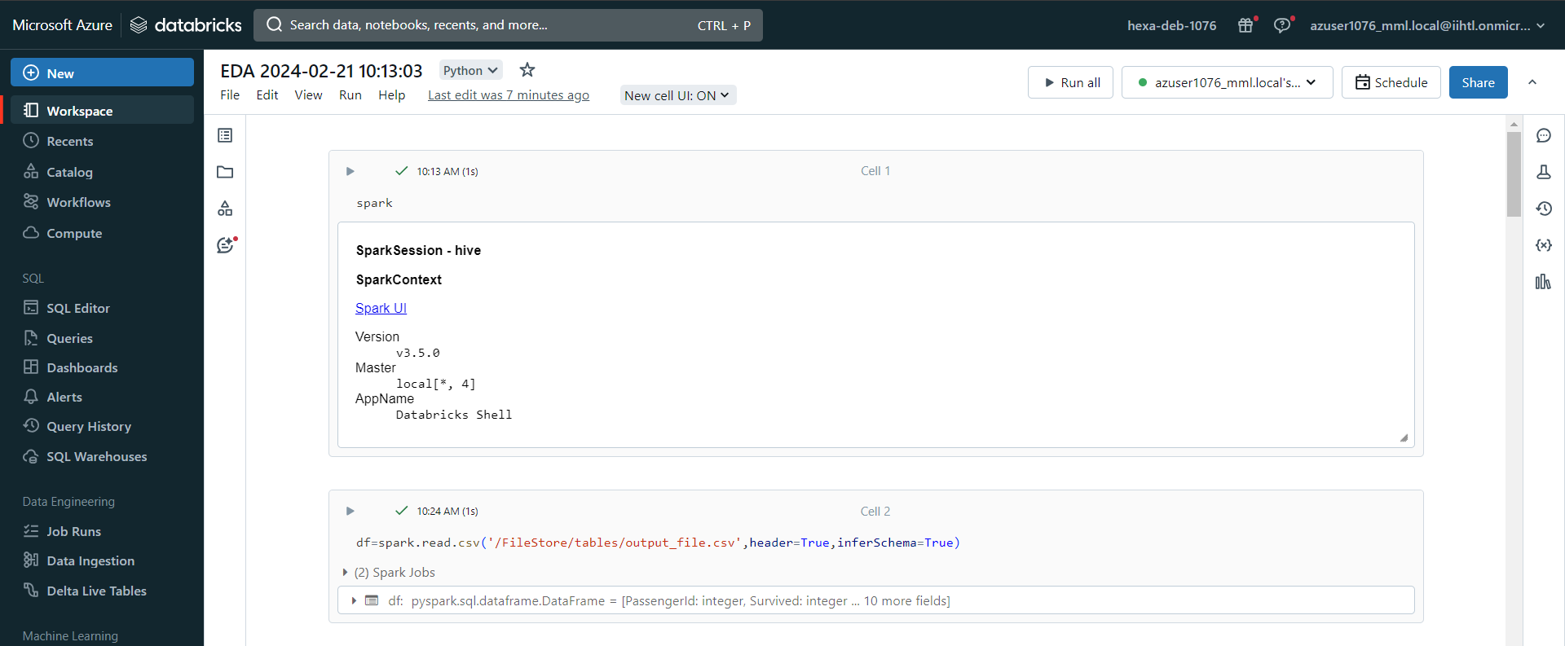

**Viewing the data:**

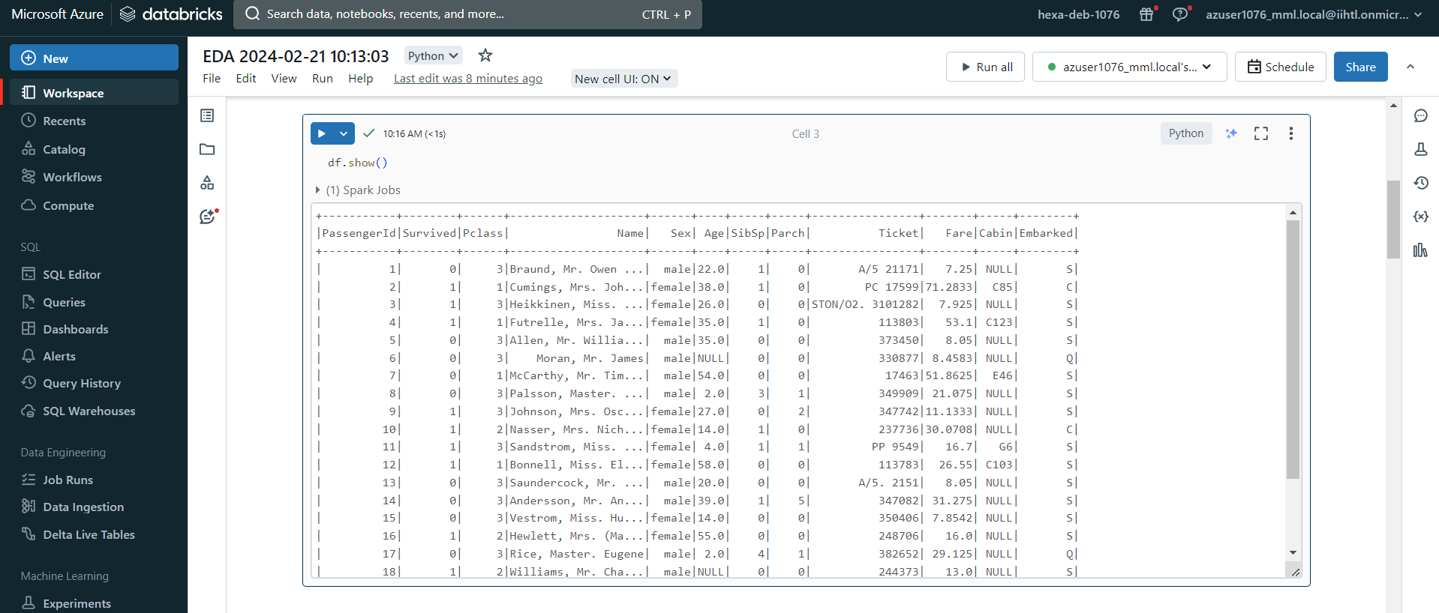

**Describing the whole dataset:**

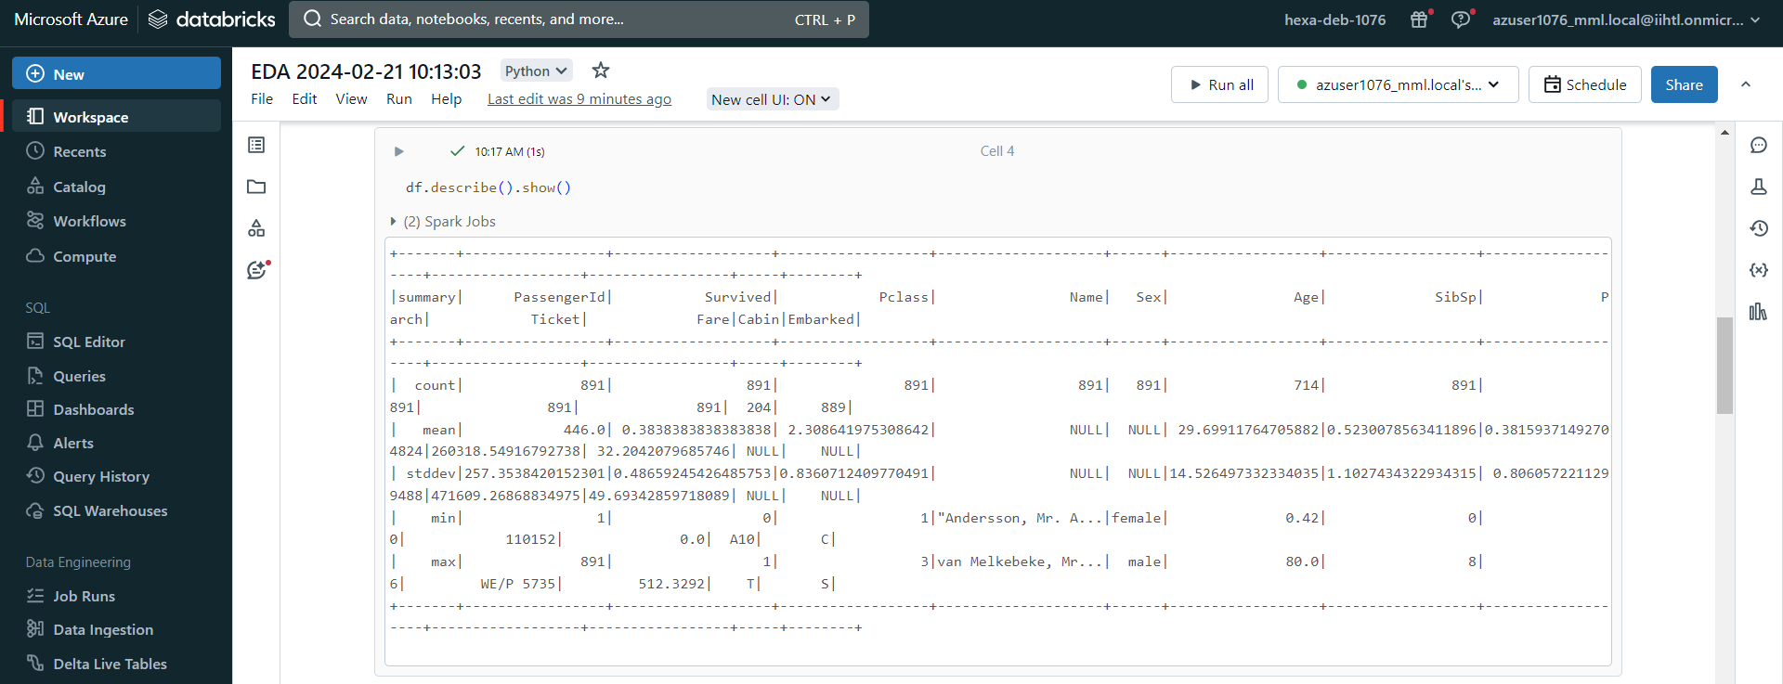

**Filtering Cabin column which contain null values:**

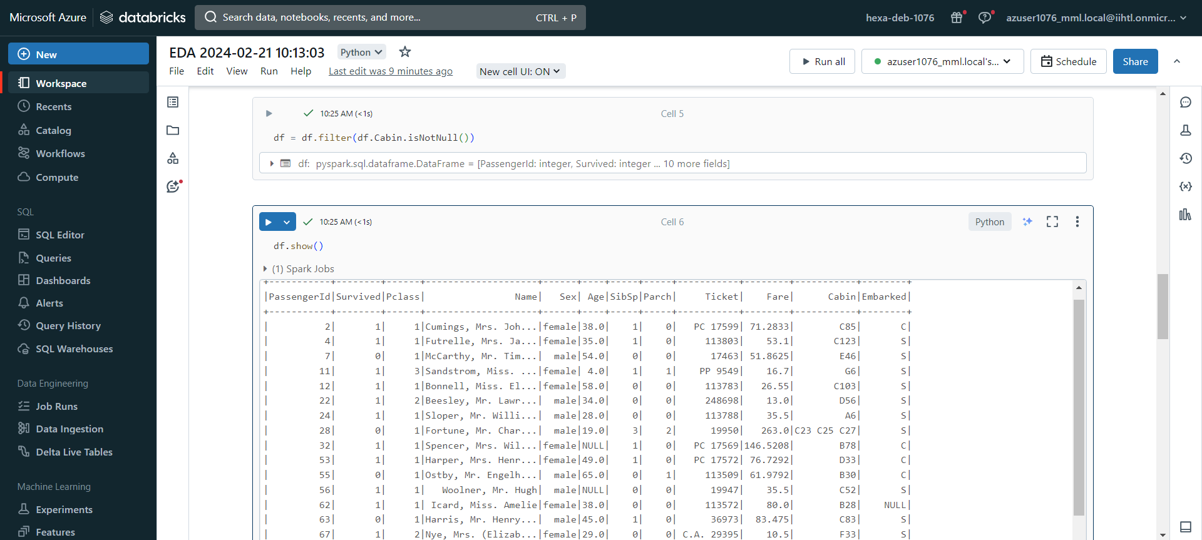

**Filtering Age column which contain null values:**

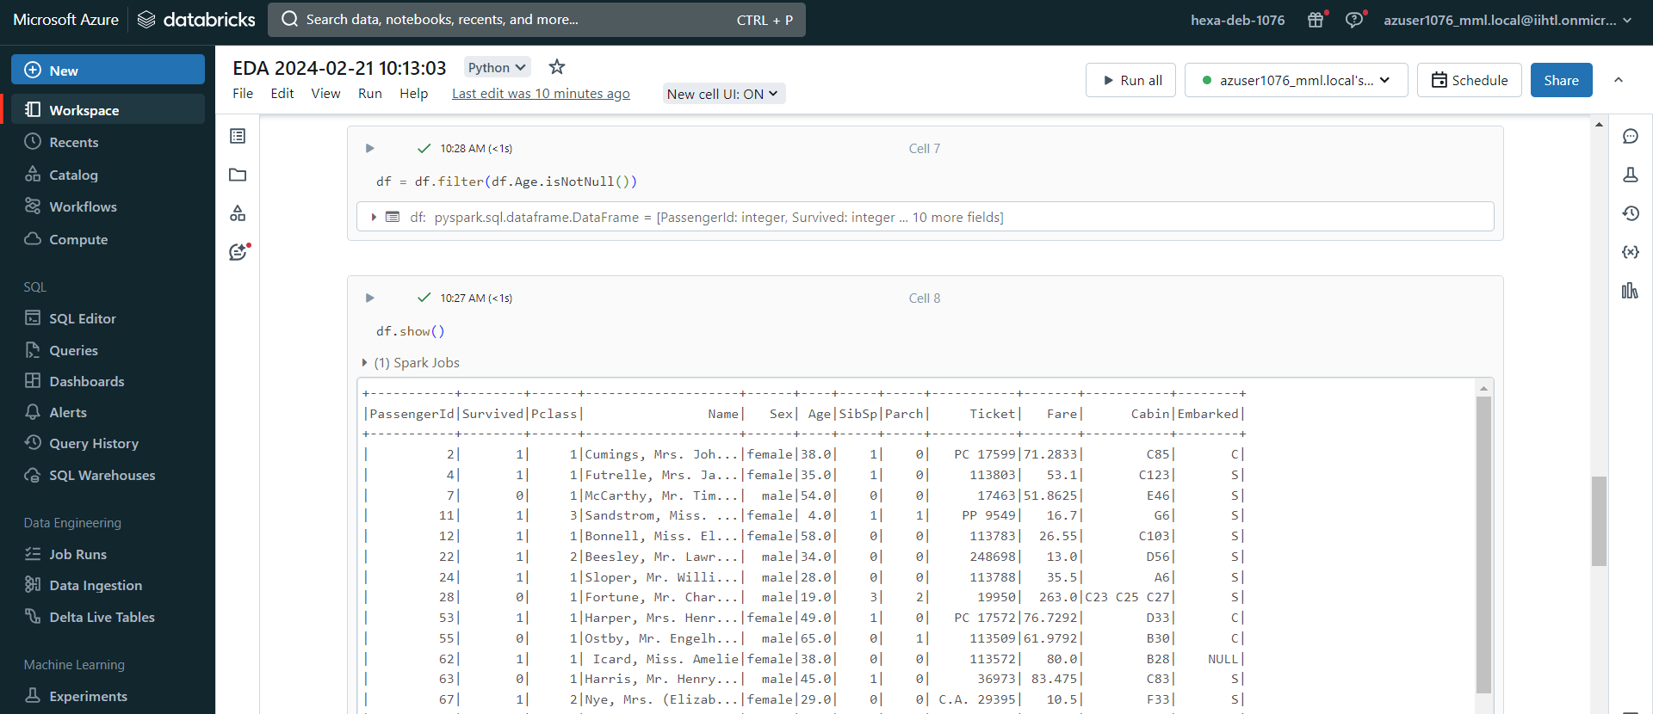

**Using Display method for Analyzing the data:**

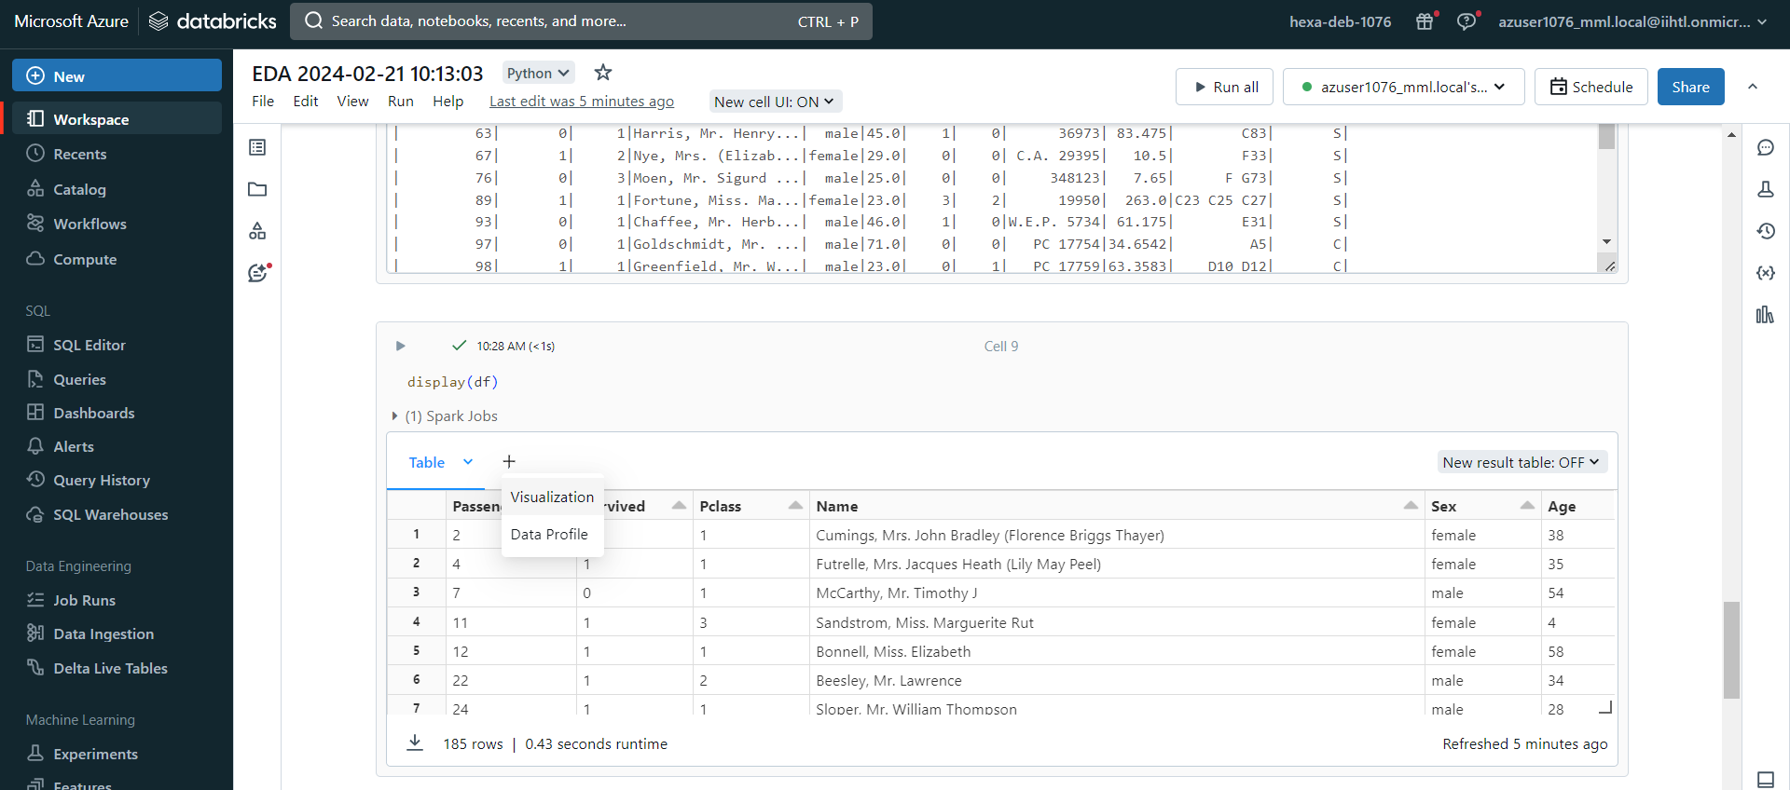

**Analysis**

**Analyzing How many people survived of particular age group and grouped by Gender:**

**Bar Graph**

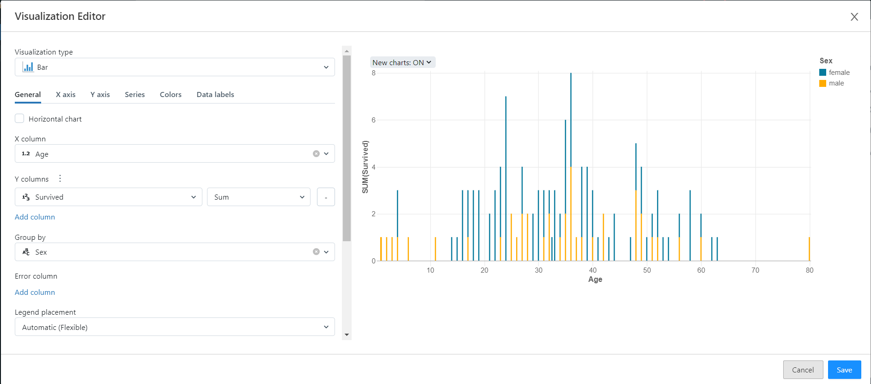

**Count of people lying in particular Ticket price:**

**Histogram:**

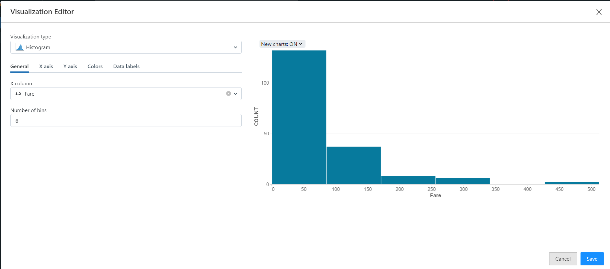

**Analysis for fare vs survived where we will come to know that higher ticket price passenger survived more or not:**

**Area chart:**

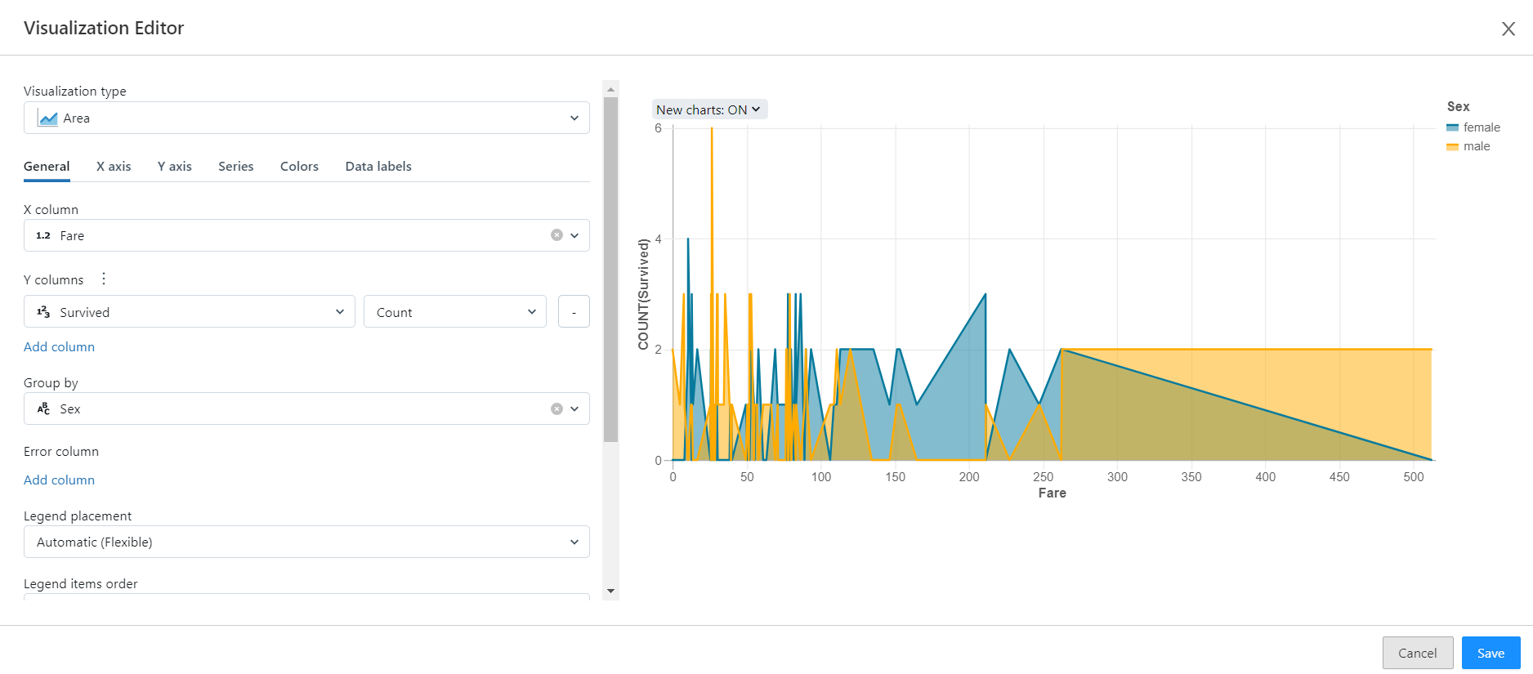

**Here we will come to know about the proportion of the gender:**

**Pie chart:**

